Corallium Rubrum Cough
BY
DR. SUBRATA K. BANERJEA
GOLD MEDALIST
B.H.M.S. (Honours in Nine Subjects of Calcutta University)
Fellow: Society of Homoeopaths, U.K
Fellow: Homoeopathic Medical Association of the United Kingdom.
Fellow: Association of Natural Medicine, U.K
Fellow: Akademie Homoopathischer Deutscher Zentralverein, Germany.
Director: Bengal Allen Medical Institute
Principal: Allen College of Homoeopathy, Essex, England

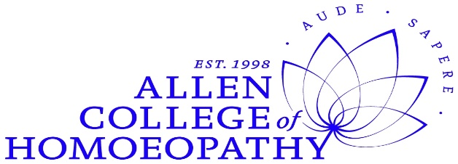

(Corallium Cough Case Video is up to 3:22)

1) Corallium Rubrum Cough Case:

I am asking him to get a X-Ray done. There is a good possibility that this is a tubercular cough.
It’s so recurrent cough.
You hear that cough ….. then SKB is mimicking the cough sound ......
Now look at Coccus Cacti and Corallium Rubrum in your Materia Medicas.
In Corallium Rubrum is written it is a machine gun cough (very rapid; the attacks follow so closely) ………… then mimicking the cough sound ......
You can prescribe by only hearing the cough sounds.
[Refer the Cough sounds Video by my son, Saptarshi: https://www.youtube.com/watch?v=wLbm_IhS1xY
And https://www.youtube.com/watch?v=PeZXpZQ2ZO4

You heard this cough.
Today I have given 2 doses of Corallium Rubrum, 30C.
This is can be a Tubercular cough.
Follow-up after 3 weeks later.
These are patches of fibrotic lesions in the lungs and you could see quite a bit of extension of the lesions.
This Xray is taken 1 month before on 6th February.
There was Corallium Rubrum prescription thereafter.
Amazing, you know, this is a real acute follow-up of an advanced pathology.
You can see the Cough is so much better in just 3 weeks.
We are talking about open case of Tuberculosis.
They generally give Streptomycin injection plus all strong Anti-tubercular modifications but this patient only having homoeopathy.
Generally within 2 to 4 weeks, these open cases of Tuberculosis becomes a closed case (meaning non-infectious).
The way he was coughing 3 weeks before and see him today after Corallium 30!
Glory goes to Hahnemann and his beautiful Homoeopathy!

ANCESTRAL TIPS ON SIXTEEN TYPES OF COUGH SOUNDS
(1) ASTHMATIC WHEEZY COUGH : Ammon Carb., Bell., Hep. Sulph., Kali.Carb., Phos., Sep.
(2) BARKING COUGH : Bell., Dros., Kali Brom., Hep. Sulph., Nit Acid., Spong., Stramo., Sambucus. Note :- Barking coughs are many times of Syphilitic taint.
(3) CATARRHAL COUGH : Ars., Capsicum, Carboveg, Dulcamara, Ipec, Phos, Sulph, Verbascum.
(4) DRY, SIBILANT COUGH : Spongia.
(5) DRY, TICKLING COUGH : Rumex.
(6) COUGH ENDS IN VOMITING : Coccus Cacti, Mephitis.
(7) FIRST ONE VIOLENT, SUCCEEDING COUGHS WEAKER AND WEAKER : Ant.Cr.
(8) HAWCKING COUGH : Sticta.
(9) RETCHING COUGH : Ant.Tart., Dros., Ipec., Nux Vom.
(10) RATTLING COUGH : Ant.Tart., Kali.Sulph., Ocimum.
(11) SHAKING, SHATTERING, CONCUSSIVE COUGH : Anac, Hyos, Lach, Lyco, Nux V., Sep, Sil, Sulph.
(12) COUGH IN ONE PAROXYSM : Calc. Carb.
(13) COUGH IN TWO PAROXYSMS : Puls, Merc.S., Phos.
(14) COUGH IN THREE PAROXYSMS : Stan.M., Cup.M.
(15) COUGH IN FOUR PAROXYSMS : Bell, Carbo Veg.
(16) "MINUTE-GUN" COUGH (BOOMS OF THE MAXIM GUN, FOLLOWING SO CLOSELY EACH OTHER) : Corallium Rub.

